Video Producer

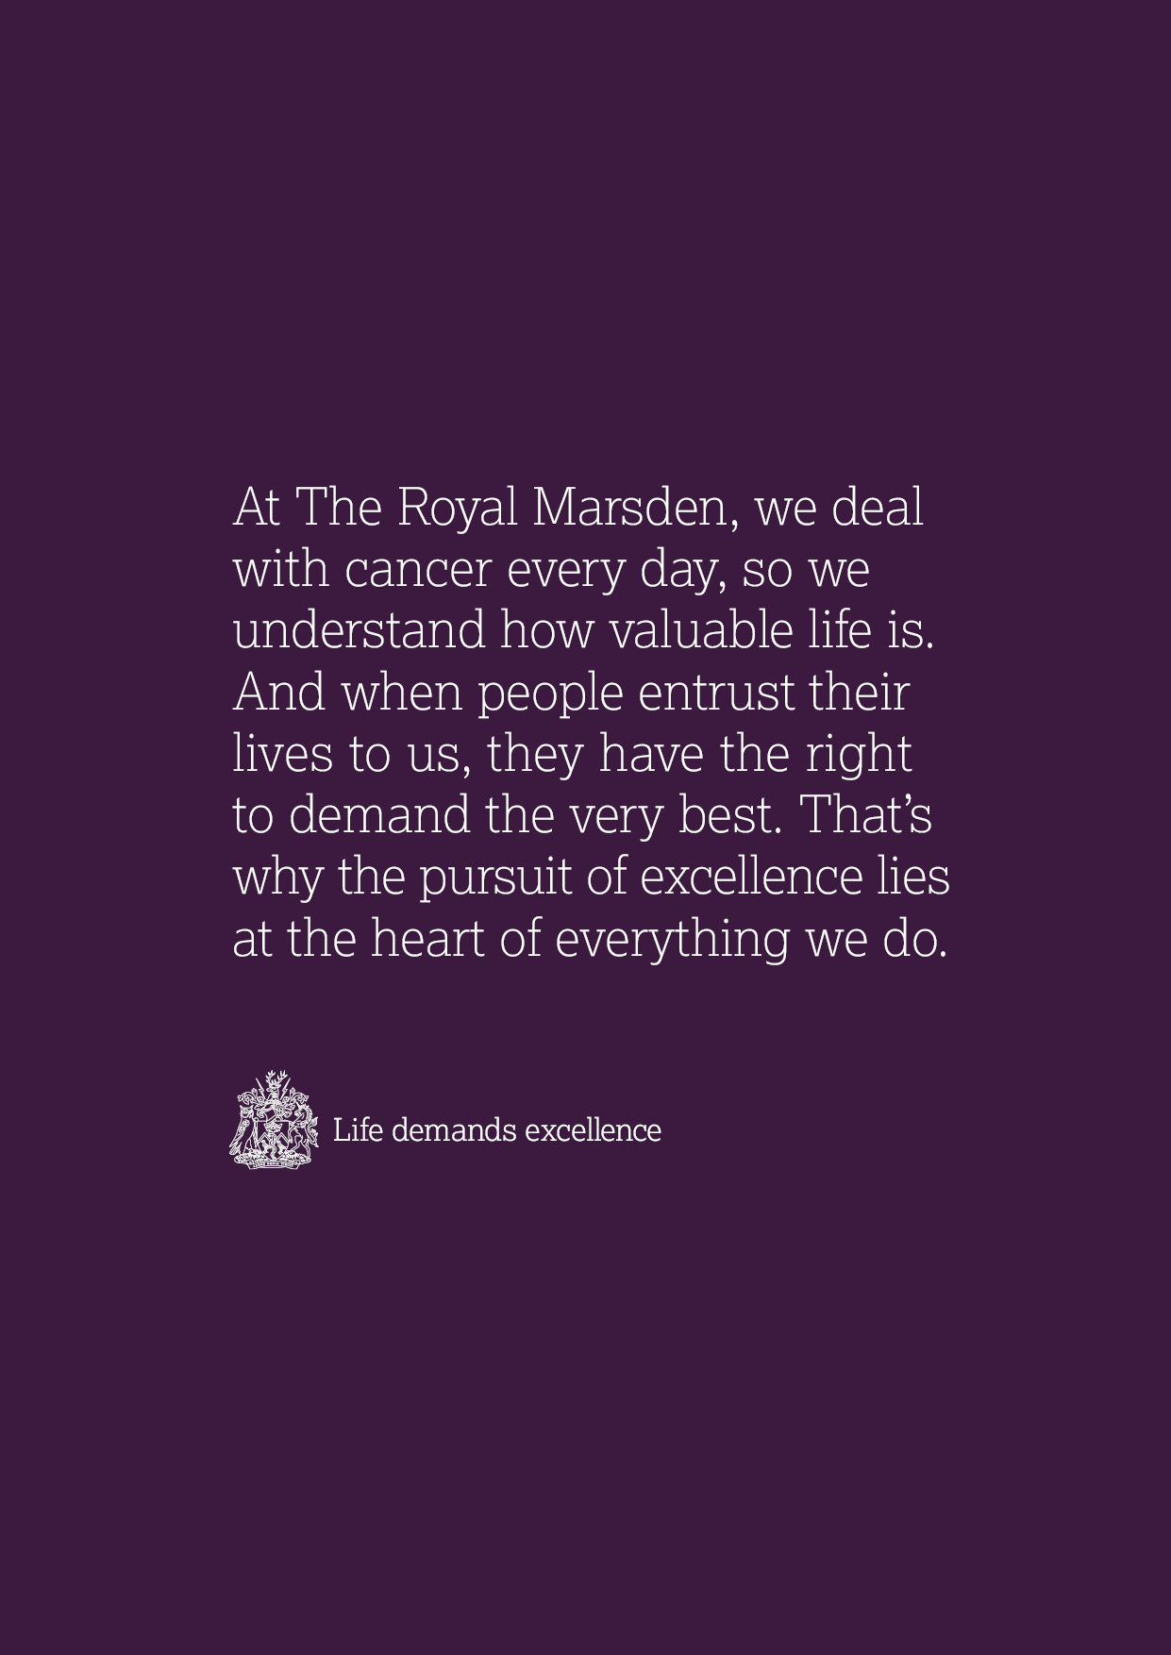

Dear candidate,

Thank you for applying to join the Marketing and Communications Department at The Royal Marsden. This candidate pack contains all you need to apply for the post.

The Royal Marsden has a vital role in championing change and improvement in cancer care through research and innovation, education and leading-edge practice. We are incredibly proud of our international reputation for pushing the boundaries and for our groundbreaking work ensuring our patients receive the very best and latest in cancer treatment and care.

The Royal Marsden Cancer Charity raises money solely to support The Royal Marsden. We ensure our nurses, doctors and research teams can provide the very best care and develop life-saving treatments, which are used across the UK and around the world.

The Marketing and Communications Department have a central role at The Royal Marsden, involved in almost every facet of the organisation, and work across the Trust, The Royal Marsden Cancer Charity, The Royal Marsden Private Care, the National Institute for Health Research Biomedical Research Centre and The Royal Marsden School.

The Marketing team has an incredibly broad remit, delivering The Royal Marsden’s Trust, Private Care and Charity marketing strategies, ensuring they support the overall business strategy for the organisation and establishing the hospital’s position as a thought leader at the forefront of worldwide cancer research and treatment.

Thank you for your interest in working for The Royal Marsden, I wish you every success in your application.

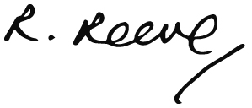

Rachael Reeve
Director, Marketing and Communications

Job title
Video Producer

Employer
The Royal Marsden NHS Foundation Trust jointly with The Royal Marsden Cancer Charity

Directorate
Marketing and Communications

Grade
Band 5

Hours of work
37.5 hours per week

Location
Based at Chelsea and Sutton

Reports to
Graphic Design Manager

Accountable to
Director of Marketing and Communications

Liaises with
Head of Marketing, Head of PR and Communications and Head of Digital, Heads of teams in the Charity and wider teams across Marketing and Communications. Various teams across the Trust. Other video agencies and freelancers. Clinical stakeholders, patients and committees.

Job summary
The Royal Marsden is a world-leading specialist cancer centre, treating and seeing over 55,000 NHS and private patients every year. It is a centre of excellence with an international reputation for groundbreaking research and the only NIHR Biomedical Research Centre for cancer. It pioneers the very latest in cancer treatments and technologies, as well as specialising in cancer diagnosis and education.

We have two hospitals: one in Chelsea, London, and another in Sutton, Surrey as well as a Medical Day Unit at Kingston Hospital. The Royal Marsden also delivers excellence in education through The Royal Marsden School and is the host organization for RM Partners, the Cancer Alliance for west London.

The Royal Marsden Cancer Charity raises money solely to support The Royal Marsden. We ensure our nurses, doctors and research teams can provide the very best care and develop life-saving treatments, which are used across the UK and around the world.

We are investing in our team and our brand, driving efficiency and undergoing a digital transformation so that we can deliver best in class experiences for all our audiences including our patients, their families, consultants, GPs, donors and supporters, and our research community.

You will work collaboratively with the Marketing, Digital, and Communications teams and colleagues in the different business areas to produce and edit videos for The Royal Marsden NHS Foundation Trust and The Royal Marsden Cancer Charity.

This role sits within the Marketing and Communications Department at The Royal Marsden NHS Foundation Trust which supports three main business areas - The Trust, Private Care and The Royal Marsden Cancer Charity. This role will sit within the marketing team and works for The Royal Marsden NHS Foundation Trust as well as The Royal Marsden Cancer Charity. The role will involve some off-site and after-hours work.

Key Skills
- Smart and passionate about how video content can be used to drive positive outcomes
- Driven and proactive team player who can prioritise his or her own work
- Able to create compelling video content with the audience in mind, always considering platform, tone, style and channel when telling a story with video
- Strong, proven video production and editing skills with thorough knowledge of digital channels used to showcase video
- Ability to solve an array of communication challenges through video
- Ability to work effectively under tight deadlines and juggle multiple projects and stakeholders
- Able to constantly respond to changing needs and priorities
- Ability to comprehend and uphold brand and style guidelines
- Strong interpersonal and communication skills, including the ability to work with people of all levels and backgrounds, from patients in the hospital to world- renowned clinicians, fundraisers and supporters, including high-value supporters.
- Ability to influence others at a senior level, both internally and externally
- A natural problem solver who thinks fast on their feet and is able to find innovative solutions
- Drives innovation and continuously looks for ways to optimise creative work
- Ability to work within a healthcare environment, including working within the hospital and with patients
- Strong knowledge of Adobe Creative Cloud software including Adobe Premiere Pro, After Effects, Photoshop and Illustrator
- Demonstrable experience of solo video and audio production to a high standard, including planning, scripting, shooting, editing and post-production, and optimising for use on specific channels
- Excellent creative judgement, able to consolidate multiple stakeholder feedback and adjust creative approach as necessary

Video Production and Creative Management
- Work collectively with the marketing team to develop and define video briefs and creative approach upfront
- Ensure projects are delivered on time and to a high level of expertise, exercising creative judgment and knowledge across all channels and problem solving where necessary
- Manage expectations of the production of video work in a busy environment
- Take responsibility for effectively resourcing workload, liaising with senior marketing managers to prioritise work with the support of the head of marketing
- Gain a full understanding of each brief and its deliverables, adhering to budgets and timings
- Prepare and present creative ideas to a range of internal stakeholders as and when required, ensuring feedback is taken into account and buy in obtained
- Ability to create on-brand graphics and animation, including video captioning, title cards and typography
- Responsible for archiving video work within the appropriate folder and date order
- Gain appropriate consent from all participants and understand how GDPR relates to video and video content

Stakeholder Management
- Work collectively with the marketing, PR and digital team to create best practice video content, including briefing, scheduling and archiving processes
- Work collaboratively with colleagues across the organisation, providing creative support to enable best in class work that supports brief requirements
- Maintain and build upon existing relationships with external suppliers

Technical Knowledge
- Experience of cross-matrix working with a wide range of internal and external stakeholders of all levels
- Advanced knowledge of Adobe Creative Cloud for editing and creating video as well as graphics and animation to support video content
- Experience at delivering against KPIs and adapting creative approach
- Excellent oral and written communication skills
- Good copywriting and scripting skills
- Good presentation skills
- Up to date with the latest creative trends

Health and Safety
- Employees must be aware of the responsibilities placed on them under the Health & Safety at Work Act (1974), to ensure that the agreed safety procedures are carried out to maintain a safe environment for employees and visitors.

Confidentiality
- Attention is drawn to the importance of the confidentiality of any information concerning patients under the care of the Trust as well as donors and supporters. Any breach of confidentiality may result in disciplinary action being taken.
- The post holder shall not use or disclose to any person either during or at any time after employment with the Trust confidential or commercially sensitive information about the business or affairs of the Trust, or about any other matters which may come to your knowledge in the course of your employment.

Trust policies
- The post holder will be subject to all The Royal Marsden NHS Foundation Trust’s Policies and Procedures.

Data protection
- All information concerning patients, staff and donors must be held in the strictest confidence and may not divulged to any unauthorised person at any time, unless to do so is in the best interest of the individual. In this instance, a Senior Manager should appropriately advise the post holder. A breach of confidentiality will result in disciplinary action in accordance with the trust’s disciplinary procedures and may lead to dismissal.
- Computer data should only be accessed if this has been authorised and is necessary as part of your work. Unauthorised access to computer data or helping others to access such data will result in disciplinary action being taken in accordance with the Trust’s disciplinary procedures and may lead to dismissal.
- The post holder’s attention is also drawn to the General Data Protection Regulation and the Computer Misuse of Act 1990.

Equal opportunities
- The Hospital is an equal opportunities employer. The unit commits itself to promoting equal opportunities in employment and will keep under review its policies and procedures to ensure that the job related needs of all staff working in the unit are recognised.
- No job applicant or employee will be discriminated against unlawfully on the grounds of race, colour, creed, nationality, ethnic or national origin, or of sex, marital status, sexual preferences or disability. Selection for training and development and promotion will be on the basis of an individual’s ability to meet the requirements of the job.

Quality assurance
- It is the post holder's responsibility to ensure that they are fully aware of the location and content of all Trust policies and procedures and comply with these as relevant to the performance of their role. Trust employees have responsibility to ensure that all data collection performed either directly or by supervised staff is accurate and timely and is in accordance with any local procedures.

No smoking
- The Trust has implemented a No Smoking Policy which applies for all staff.

Dress code
- All staff are expected to abide by the Trust’s staff dress code.

Employee specification
All suitably qualified applicants will be granted an interview

Candidates must be able to demonstrate | Essential or Desirable | Assessed by

Education/Qualifications
Video production related degree or qualification | Essential | Application form

Experience
- Demonstrable experience of solo video and audio production to a high standard, including planning, shooting, editing and post production, and optimisation for channels | Essential | Application form and interview
- Experience of creating materials to meet brand guidelines | Essential | Application form and interview
- Understanding of the various media platforms on which video content can be shared and what content works best for each one | Essential | Interview
- Managing a range of projects on time, within budget and to the agreed standards | Essential | Interview

Skills/Abilities/Knowledge
- Excellent understanding of brand and its role within an organisation | Essential |  | Application form / Interview
- Advanced hands-on knowledge of Adobe Creative Cloud in order to produce and present information to diverse audiences | Essential |  | Interview
- Strong project management skills needed to independently plan and manage logistics for video shoots, including scheduling locations and case studies | Essential |  | Interview
- Advanced knowledge of video channels, including how to create and optimise video to perform best within certain channels | Essential |  | Application form/interview
- Strong interpersonal skills and the ability to manage senior stakeholders | Essential |  | Application form/interview
The above attributes have been identified by management to be necessary for this post, and will be used when short listing applicants for interview.

